**Dev-Ops Project-2**

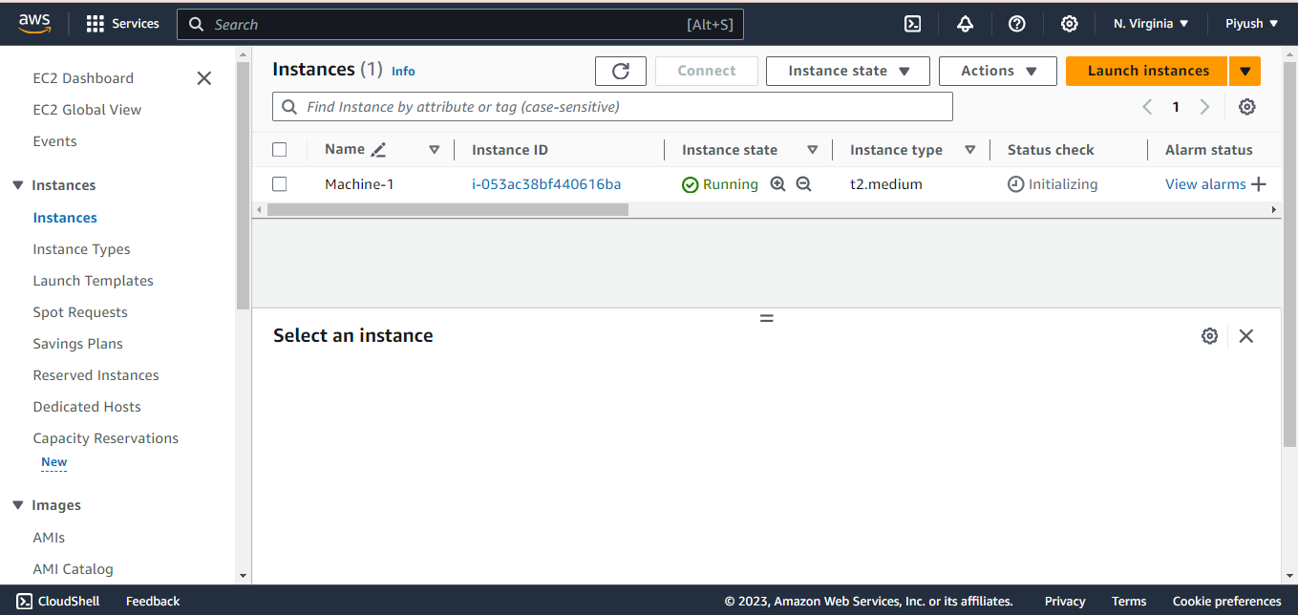

**Installed Terraform in Machine-1**  
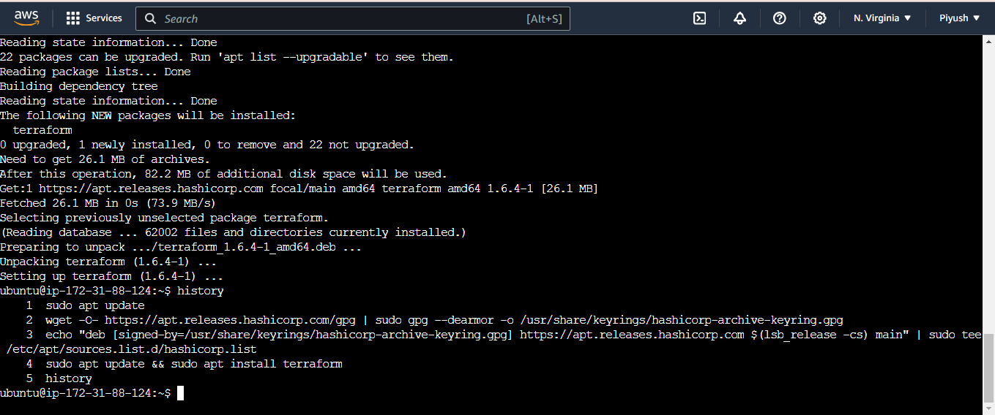 **Terraform code to launch 3 machines on AWS in ‘main.tf’ file.  
1 Master and 2 Slaves**(

provider "aws" {

region = "us-east-1"

access_key = "AKIAZQTWTCGWKXZA7T"

secret_key = "M/6NPr+U9irSzKt0hFYXNohGNfOiemet3qr+kh"

}

resource "aws_instance" "K8s-Master" {

ami = "ami-06aa3f7caf3a30282"

instance_type = "t3.micro"

key_name = "Project-2"

tags = {

Name = "Machine-3"

}

}

resource "aws_instance" "K8s-Slave-1" {

ami = "ami-06aa3f7caf3a30282"

instance_type = "t3.micro"

key_name = "Project-2"

tags = {

Name = "Machine-2"

}

}

resource "aws_instance" "K8s-Slave-2" {

ami = "ami-06aa3f7caf3a30282"

instance_type = "t3.micro"

key_name = "Project-2"

tags = {

Name = "Machine-4"

}

}

)

**Apply the Terraform code**

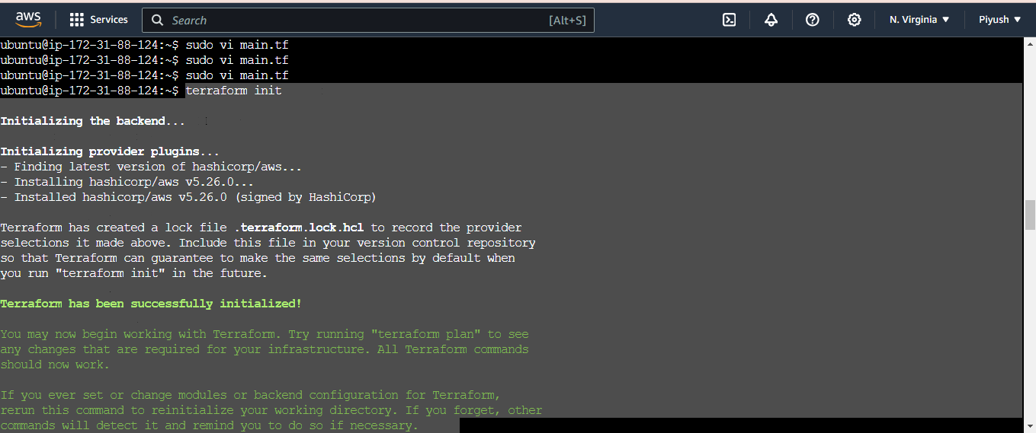

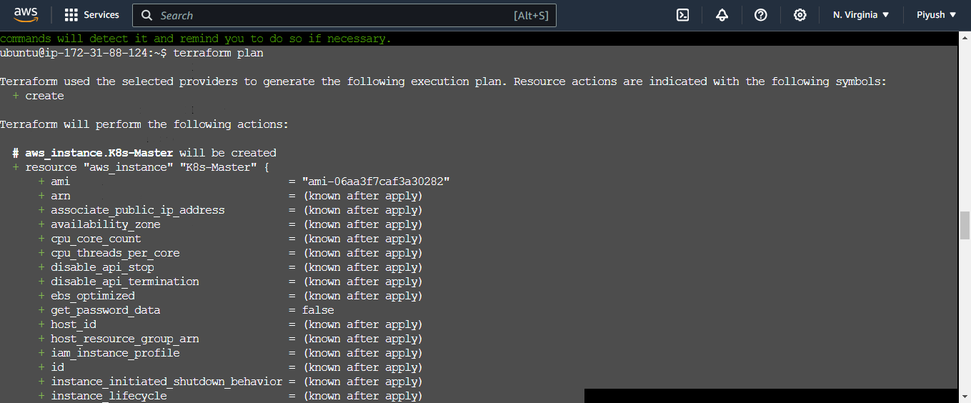

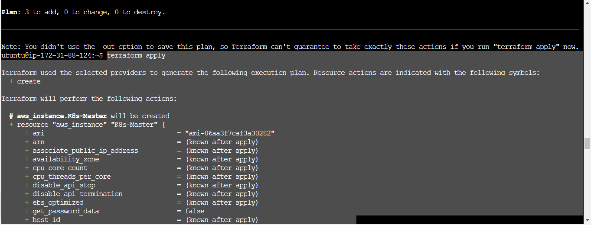

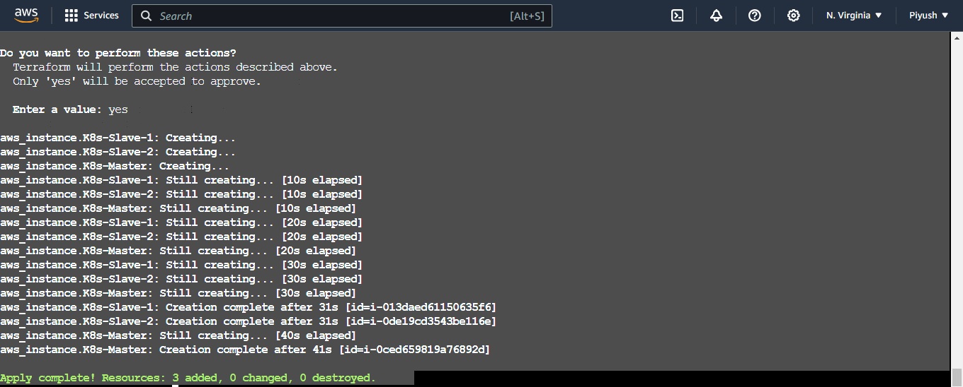

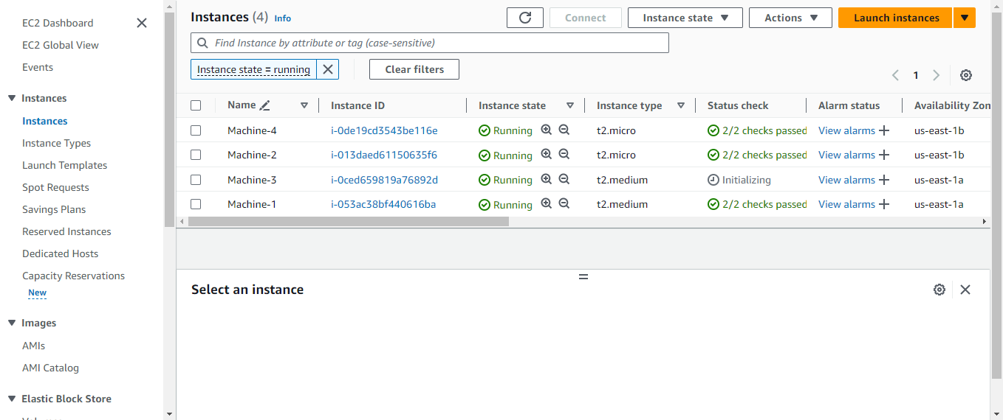

**Installed Ansible in Machine-1**

$ sudo apt update

$ sudo apt install software-properties-common

$ sudo add-apt-repository --yes --update ppa:ansible/ansible

$ sudo apt install ansible

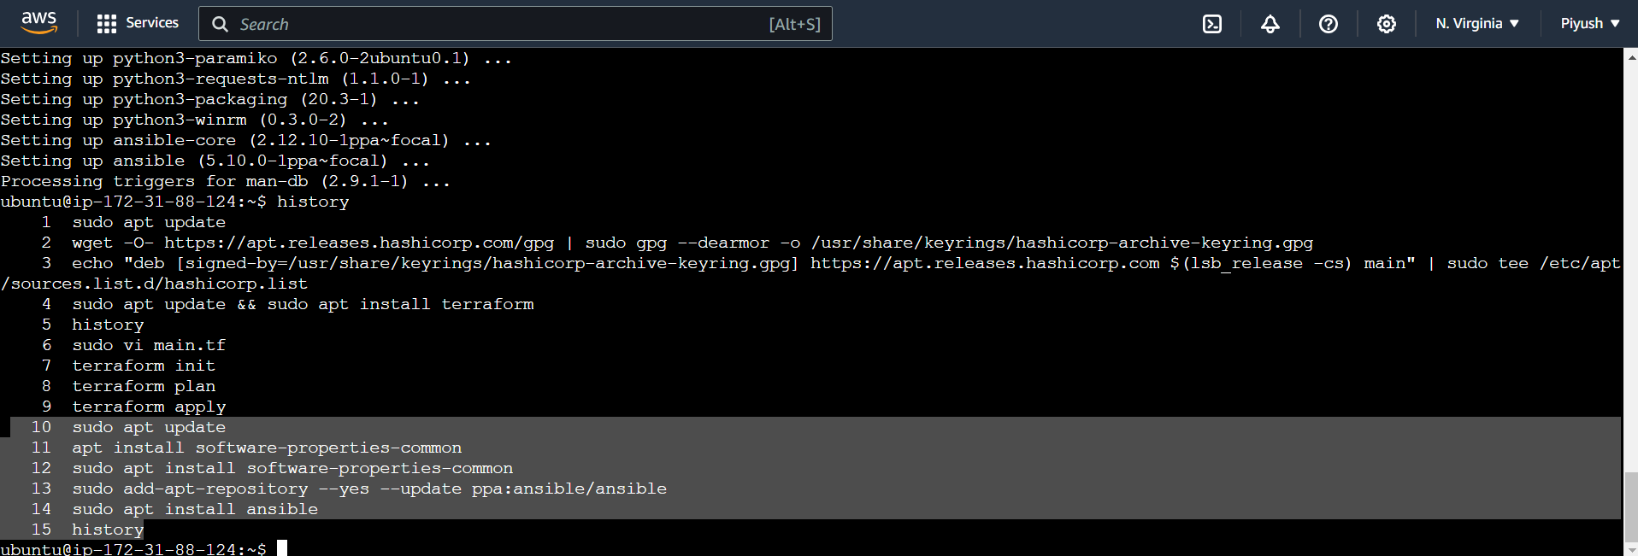

ON Ansible Machine-1

10 sudo apt update

11 apt install software-properties-common

12 sudo apt install software-properties-common

13 sudo add-apt-repository --yes --update ppa:ansible/ansible

14 sudo apt install ansible

15 history

16 ls

17 ssh-keygen

18 cd .ssh

19 ls

20 cat id_rsa.pub **[copy the key and paste it in the slaves (in sudo vi .ssh/authorized_keys)]**

21 cd

22 sudo vi /etc/ansible/hosts

(copy-paste the ip address in hosts file)

*[master]*

*172.31.86.227*

*[slaves]*

*172.31.16.190*

*172.31.22.167*

23 ansible -m ping all

24 history

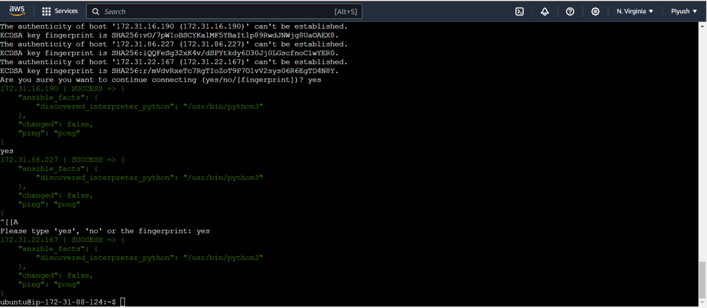

**script1.sh** - [install Jenkins on Machine-1]

(sudo wget -O /usr/share/keyrings/jenkins-keyring.asc \

https://pkg.jenkins.io/debian-stable/jenkins.io-2023.key

echo deb [signed-by=/usr/share/keyrings/jenkins-keyring.asc] \

https://pkg.jenkins.io/debian-stable binary/ | sudo tee \

/etc/apt/sources.list.d/jenkins.list > /dev/null

sudo apt-get update

sudo apt-get install jenkins –y )

**script2.sh** [install Java,docker,K8s on Machine-3]

(sudo apt update

sudo apt install openjdk-11-jdk -y

sudo apt install docker.io -y

sudo apt update

sudo apt upgrade -y

sudo apt install -y curl apt-transport-https ca-certificates software-properties-common

curl -s https://packages.cloud.google.com/apt/doc/apt-key.gpg | sudo apt-key add -

sudo add-apt-repository "deb http://apt.kubernetes.io/ kubernetes-xenial main"

sudo swapoff -a

sudo apt update

sudo apt install -y kubelet kubeadm kubectl)

**script3.sh** [install Java,docker,K8s on Machine-2 and Machine-4]

(sudo apt update

sudo apt install docker.io -y

sudo apt update

sudo apt upgrade -y

sudo apt install -y curl apt-transport-https ca-certificates software-properties-common

curl -s https://packages.cloud.google.com/apt/doc/apt-key.gpg | sudo apt-key add -

sudo add-apt-repository "deb http://apt.kubernetes.io/ kubernetes-xenial main"

sudo swapoff -a

sudo apt update

sudo apt install -y kubelet kubeadm kubectl)

**play.yaml** [ runs ansible playbook ]

(

---

- name: install Jenkins and Java on Machine-1

become: true

hosts: localhost

tasks:

- name: running script1

script: script1.sh

- name: install K8s and Java on Machine-3

become: true

hosts: master

tasks:

- name: running script2

script: script2.sh

- name: install K8s and Java on Machine-2 and Machine-4

become: true

hosts: slaves

tasks:

- name: running script3

script: script3.sh

)

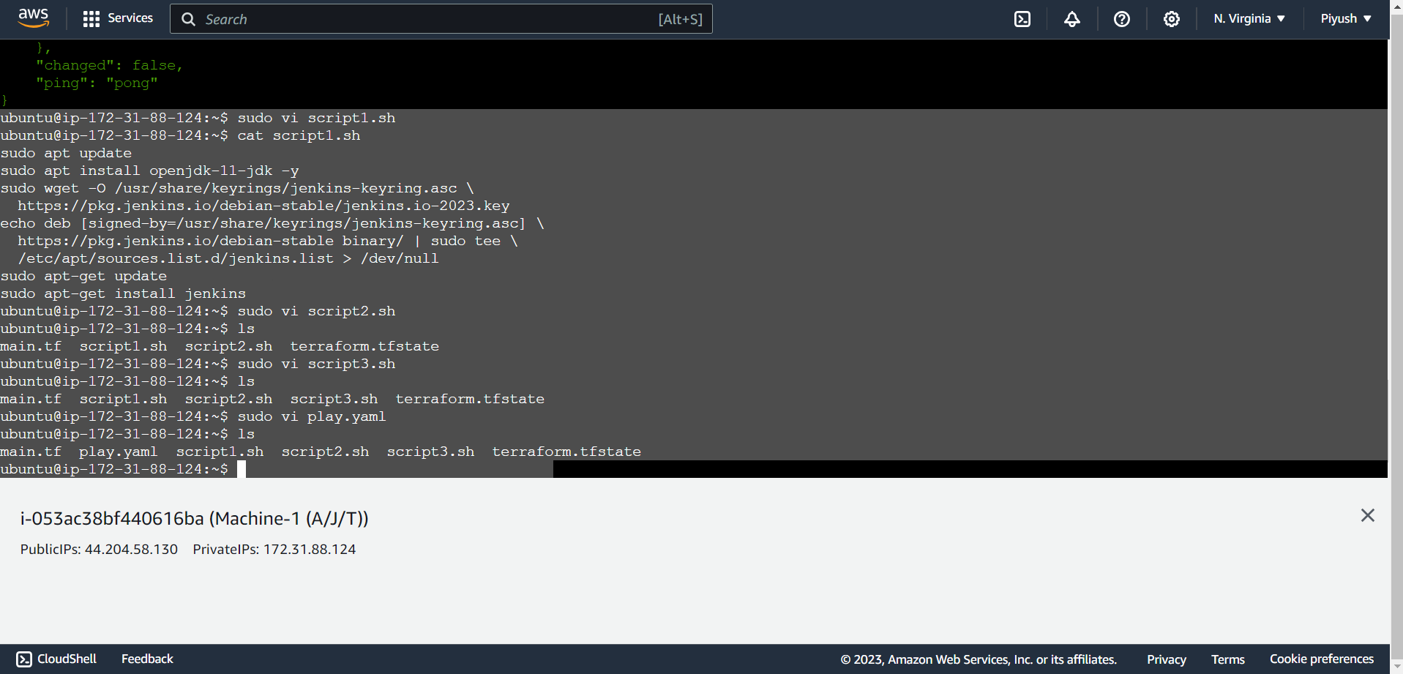

**ansible-playbook play.yaml --syntax-check**

**ansible-playbook play.yaml –check**

**ansible-playbook play.yaml**

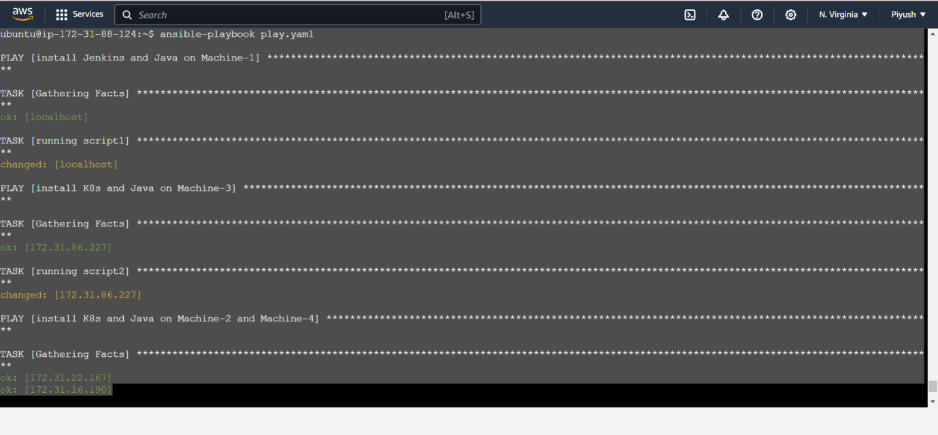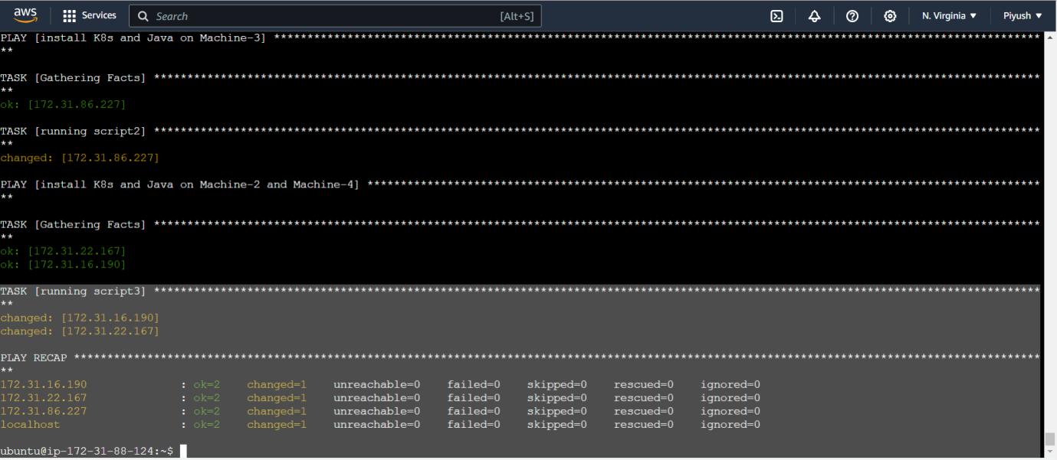

**Kubernetes is installed on Machine-3**

sudo kubeadm init

mkdir -p $HOME/.kube

sudo cp -i /etc/kubernetes/admin.conf $HOME/.kube/config

sudo chown $(id -u):$(id -g) $HOME/.kube/config

kubectl apply -f <https://github.com/weaveworks/weave/releases/download/v2.8.1/weave-> daemonset-k8s.yaml

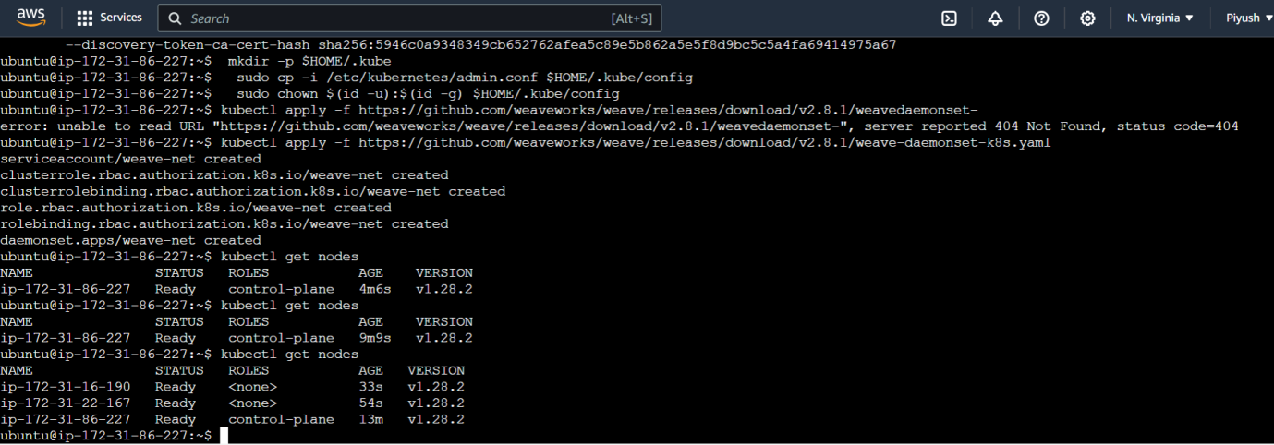

**Jenkins is installed on Machine-1**

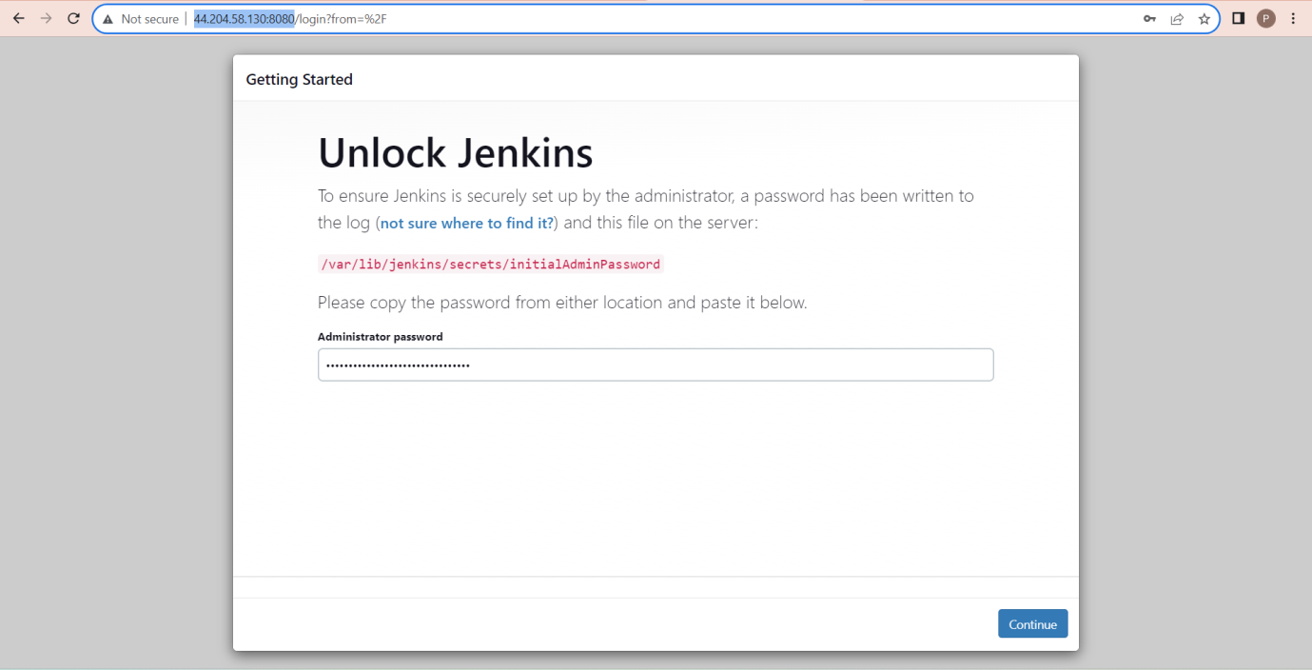

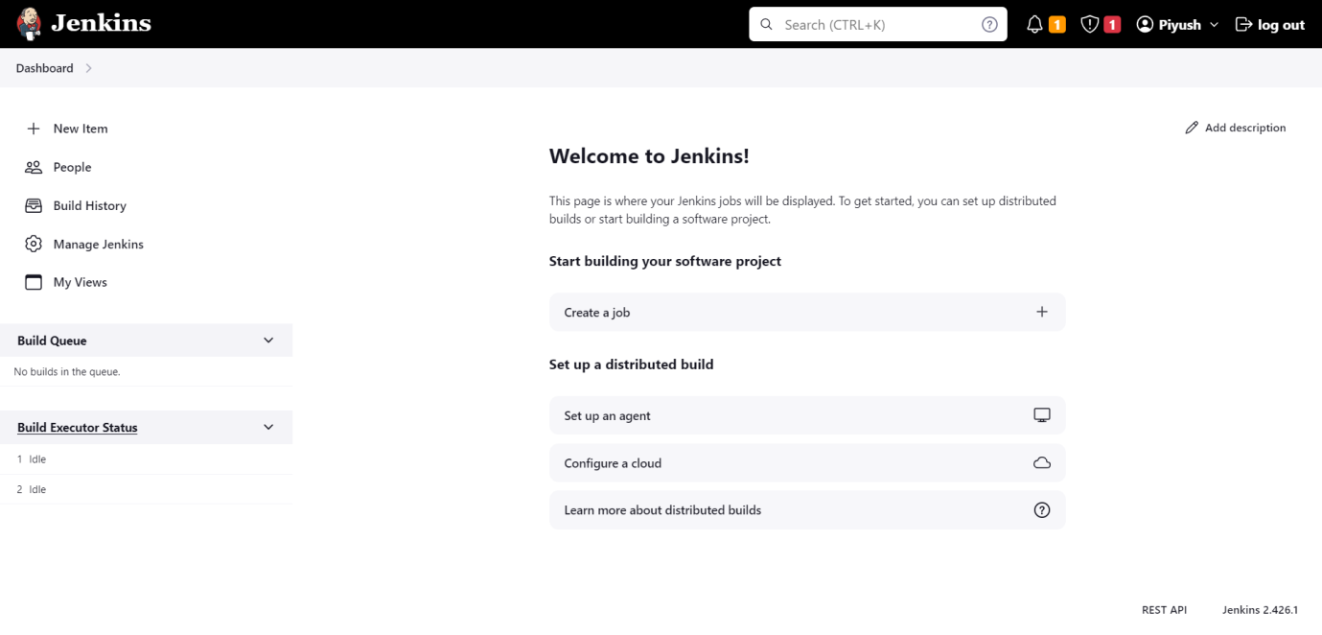

**Added a Node in Jenkins as K8s-Master (Machine-3)**

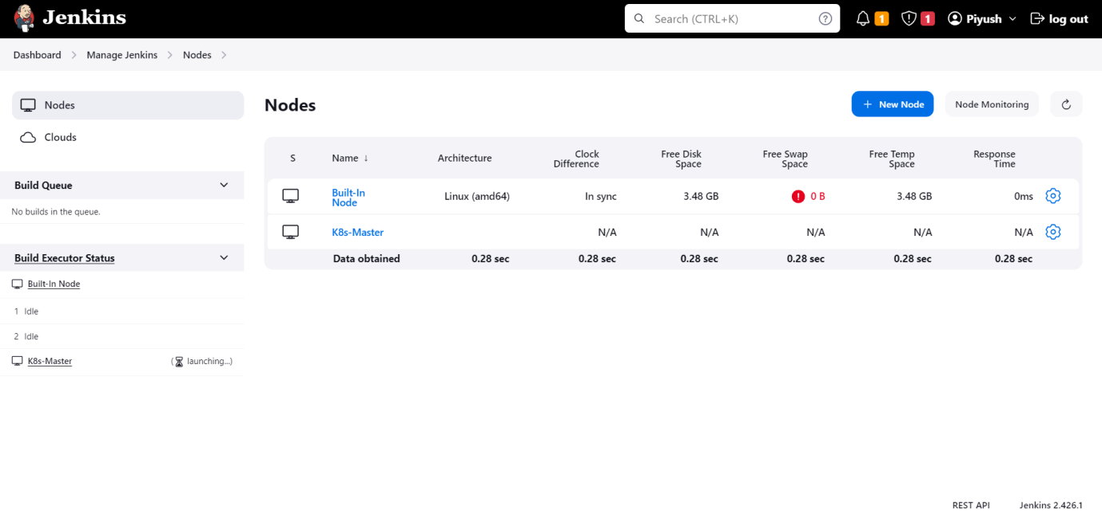

**Created credentials same as Dockerhubs.**

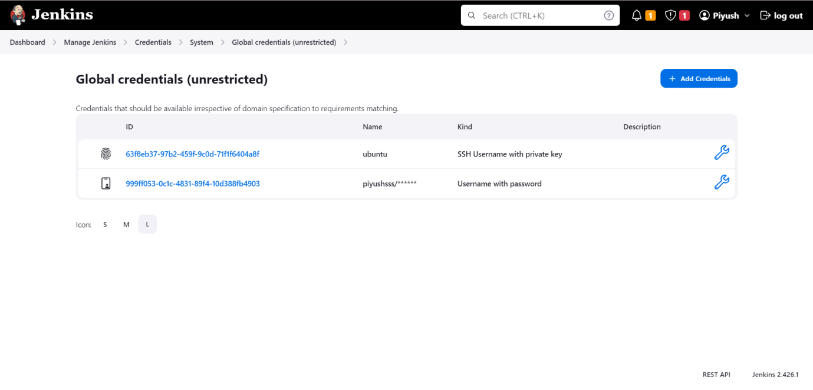

**Created a Docker file in Github repository.**

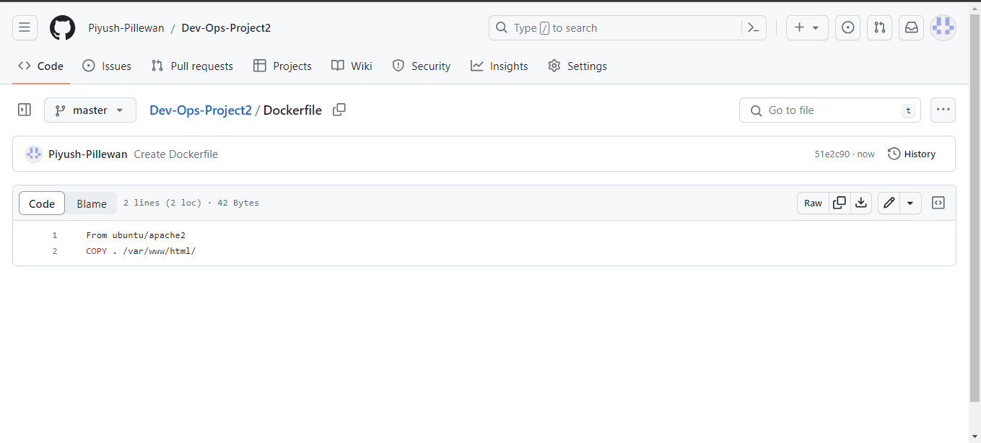

**Pipeline Script**

pipeline {

agent none

environment {

DOCKERHUB_CREDENTIALS=credentials('999ff053-0c1c-4831-89f4-10d388fb4903')

}

stages {

stage('Hello') {

steps {

echo 'Hello World'

}

}

stage('Git') {

agent {

label 'K8s-Master'

}

steps {

git 'https://github.com/Piyush-Pillewan/Dev-Ops-Project2.git'

}

}

stage('Docker') {

agent {

label 'K8s-Master'

}

steps {

sh 'sudo docker build /home/ubuntu/workspace/testpipeline -t piyushsss/project2'

sh 'sudo echo $DOCKERHUB_CREDENTIALS_PSW | sudo docker login -u $DOCKERHUB_CREDENTIALS_USR --password-stdin'

sh 'sudo docker push piyushsss/project2'

}

}

stage('K8s') {

agent {

label 'K8s-Master'

}

steps {

sh 'kubectl delete deploy nginx-deployment'

sh 'kubectl apply -f deployment.yaml'

sh 'kubectl apply -f service.yaml'

}

}

}

}



